Technology Use Form (TUF) Key Points

- The online Technology Use Form (TUF) is used for employees to either request reimbursement for their own personal wireless device being used for ASU business, or if they have an ASU provided wireless device that is covered by a monthly service plan.

- Wireless devices include phones, tablets, and data cards.

- If you have multiple wireless devices used for ASU business, please submit a separate TUF form for each device.

- All requests will be reviewed and approved by the College/Dean.

- Requests should not cross multiple fiscal years and will end on June 30th.

- Requests or renewals submitted for the new fiscal year must be submitted by June 15th annually. This means both the TUF form and documentation must be submitted by this date to ensure reimbursements start with the first payroll of the new fiscal year. Requests for reimbursement submitted after this date will begin within 1-2 pay periods after the form has been fully approved.

- Reimbursements cannot exceed the actual cost to the employee. Documentation (monthly bill) must be submitted to confirm the reimbursement amount.

- Reimbursements should not exceed $60.00 per month ($30.00 per pay period) for a phone device, or $40.00 per month ($20.00 per pay period) for other devices. Requests for a higher amount will require additional justification and may require additional approvals. Note: Monthly reimbursements greater than the amounts listed above will be considered taxable income.

- Grant Funded Reimbursements – Please check with the College’s Research Advancement Office (RAO) at raopost@asu.edu or your Center’s Business Manager prior to submitting your TUF to ensure the cost is allowable on the grant. If the cost is allowable, please indicate in Step 18 that RAO or your Center Business Manager has approved the cost.

- Reimbursements cannot be back dated.

- Reimbursements occur two times per month. If there are three pay dates in one month, reimbursement will be provided on the first two pay dates of the month.

- If you have any questions, please contact Taylor Gunder at tmblank@mainex1.asu.edu.

Submitting a Request

Step 1 Go to https://fsforms.asu.edu/techuse/index.html

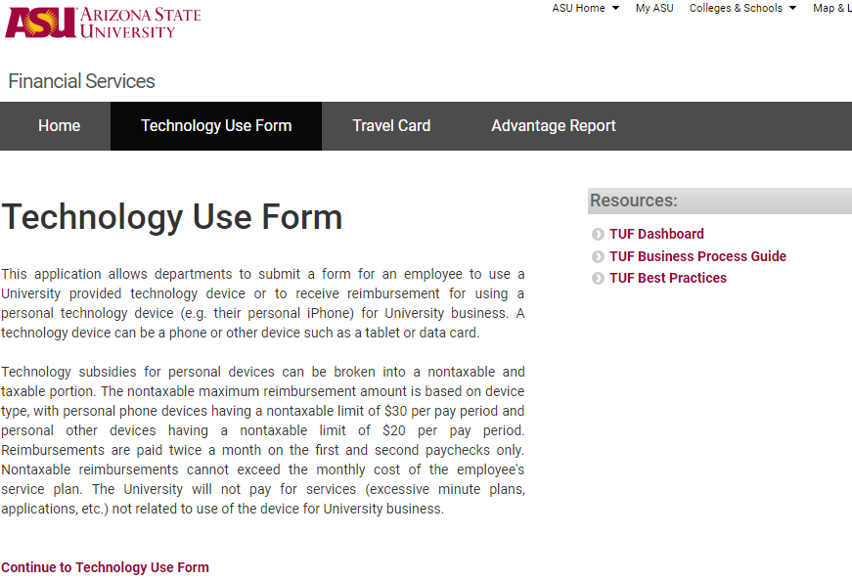

Step 2 Click on Continue to Technology Use Form

Step 3 Log in using your ASURITE ID and Password (if required)

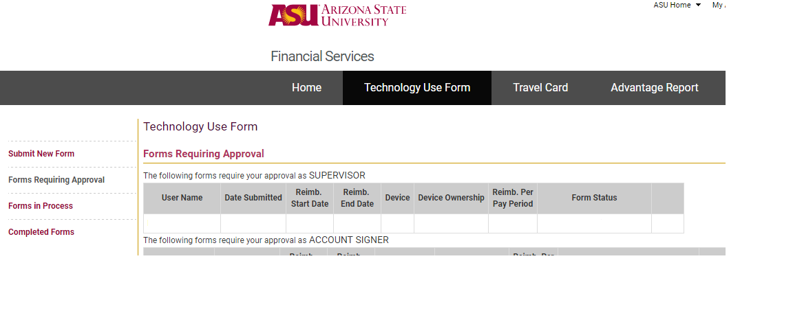

Step 4 Click on Submit New Form
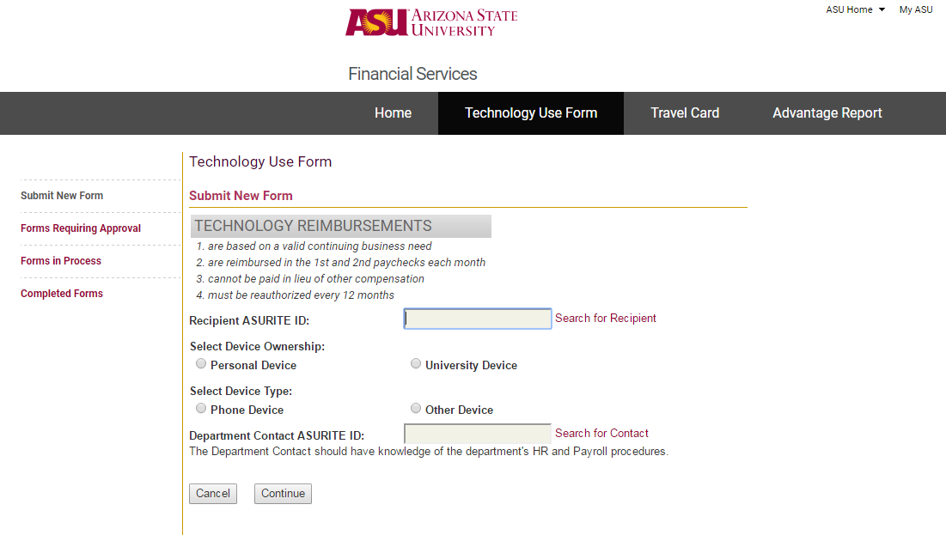

Step 5 Recipient ASURITE ID - Enter your ASURITE ID

Step 6 Select Device Ownership – choose either “Personal Device” or “University Device”

“Personal Device” - means you own the device and your department reimburses you for ASU business related charges

“University Device” - means the device was purchased by the University and monthly expenses are paid for directly by the University

Note: If you choose “University Device” instead of “Personal Device”, the option to enter an amount for reimbursement will be removed from the form.

Step 7 Select Device Type – Chose either “Phone Device” or “Other Device” (i.e. tablet)

Step 8 Department Contact ASURITE ID - Enter tmblank

Note: Entering an ASURITE ID other than tmblank will delay the processing of your request and a new Technology Use Form may need to be submitted.

Step 9 Click on Continue
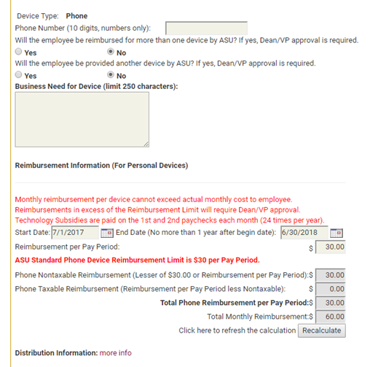

Step 10 If “Phone Device” was selected in Step 7, enter the Phone Number (numbers only, no dashes). If “Other Device” was selected, enter the Device Type (tablet, etc.) and Device Serial Number.

Step 11 Reimbursed for more than one device? - Select “Yes” or “No”

Step 12 Provided another device by ASU? - Select “Yes” or “No”

Step 13 Business Need for Device - Information provided for this question needs to demonstrate a true business purpose. Further explanation will be requested if the information provided does not meet this requirement.

Steps 14 – 16: Personal Devices Only
Step 14 Start Date - If requesting reimbursement for the upcoming fiscal year, enter July 1. If requesting reimbursement for the remainder of the current fiscal year, enter today’s date.

Reminder: The start date cannot be back dated.

Step 15 End Date – Enter June 30 of the fiscal year requested.

Step 16 Reimbursement per Pay Period - Enter the amount to be reimbursed per pay period; this is half of your total monthly reimbursement
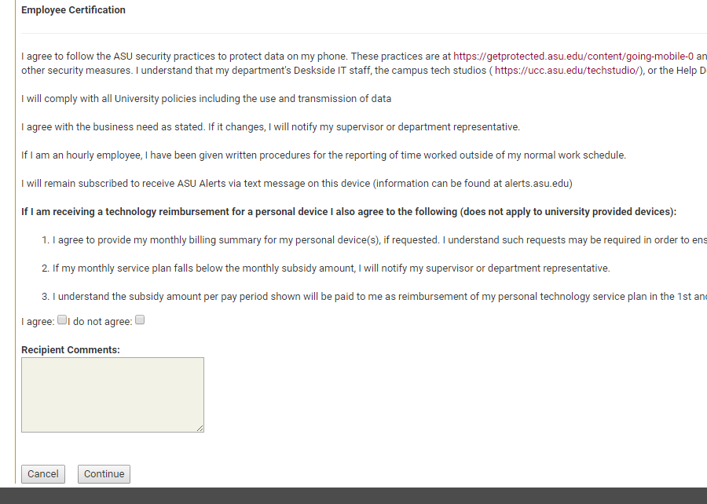

Step 17 Read the Employee Certification. Check the box for either “I agree” or “I do not agree”.

Note: If you choose “I do not agree”, your form will be canceled.

Step 18 Recipient Comments - Add any necessary comments in this box. This may include updating the account number if needed or noting that RAO/Center Business Manager has approved the request for reimbursement on the grant.

Step 19 Click on Continue

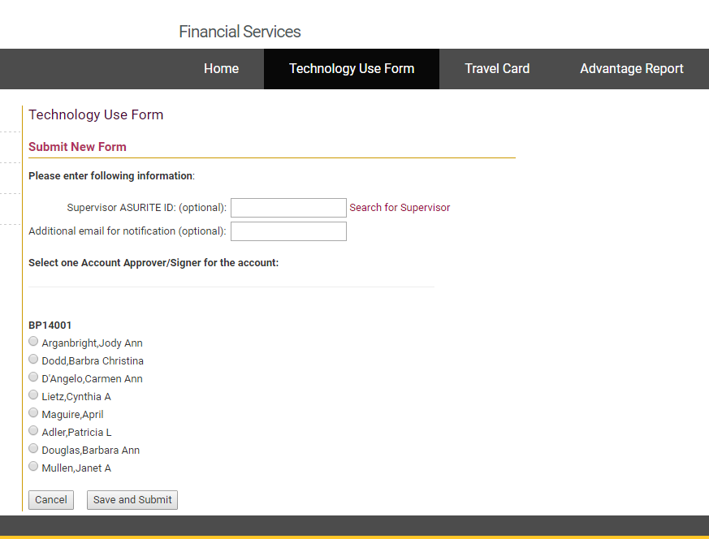

Step 20 Supervisor ASURITE ID – Enter your supervisor’s ASURITE ID. Use the Search for Supervisor link if you do not know the ASURITE ID.

Note: This step is not optional. Your supervisor must approve this form. Your form will be canceled if it is submitted without a supervisor and a new form will need to be submitted.

Step 21 Select Account Approver/Signer – select Mizell, Shimara.

Step 22 Click Save and Submit

Step 23 Send a copy of your monthly bill to Shimara Mizell for review. Charges in your bill should be easy to identify and be at least the amount requested for reimbursement. Please highlight your individual charges.

Email – Shimara.Mizell@asu.edu
Interoffice Mail – CBS mail box in UCENT Suite 750
In Person – UCENT 741

Note: Your TUF form will not be approved without review of your monthly bill.

